1.Creation of Amazon EC2 Instances (Linux and Windows) and Establishing Secure Connections Using SSH from Local Machine, PuTTY (.pem & .ppk), AWS CloudShell, and Remote Desktop Protocol (RDP)

🧾 PREREQUISITES
Make sure you have:
- ✅ EC2 Ubuntu instance running
- ✅ .ppk private key file
- ✅ PuTTY installed (Windows)-- https://putty.org/index.html (INSTALL FIRST ONE)

🔹 STEP 1: Check Security Group
Go to EC2 → Security Groups → Inbound rules
Ensure this rule exists:
Type: SSH
Port: 22
Source: My IP
❌ If SSH is blocked → connection will fail
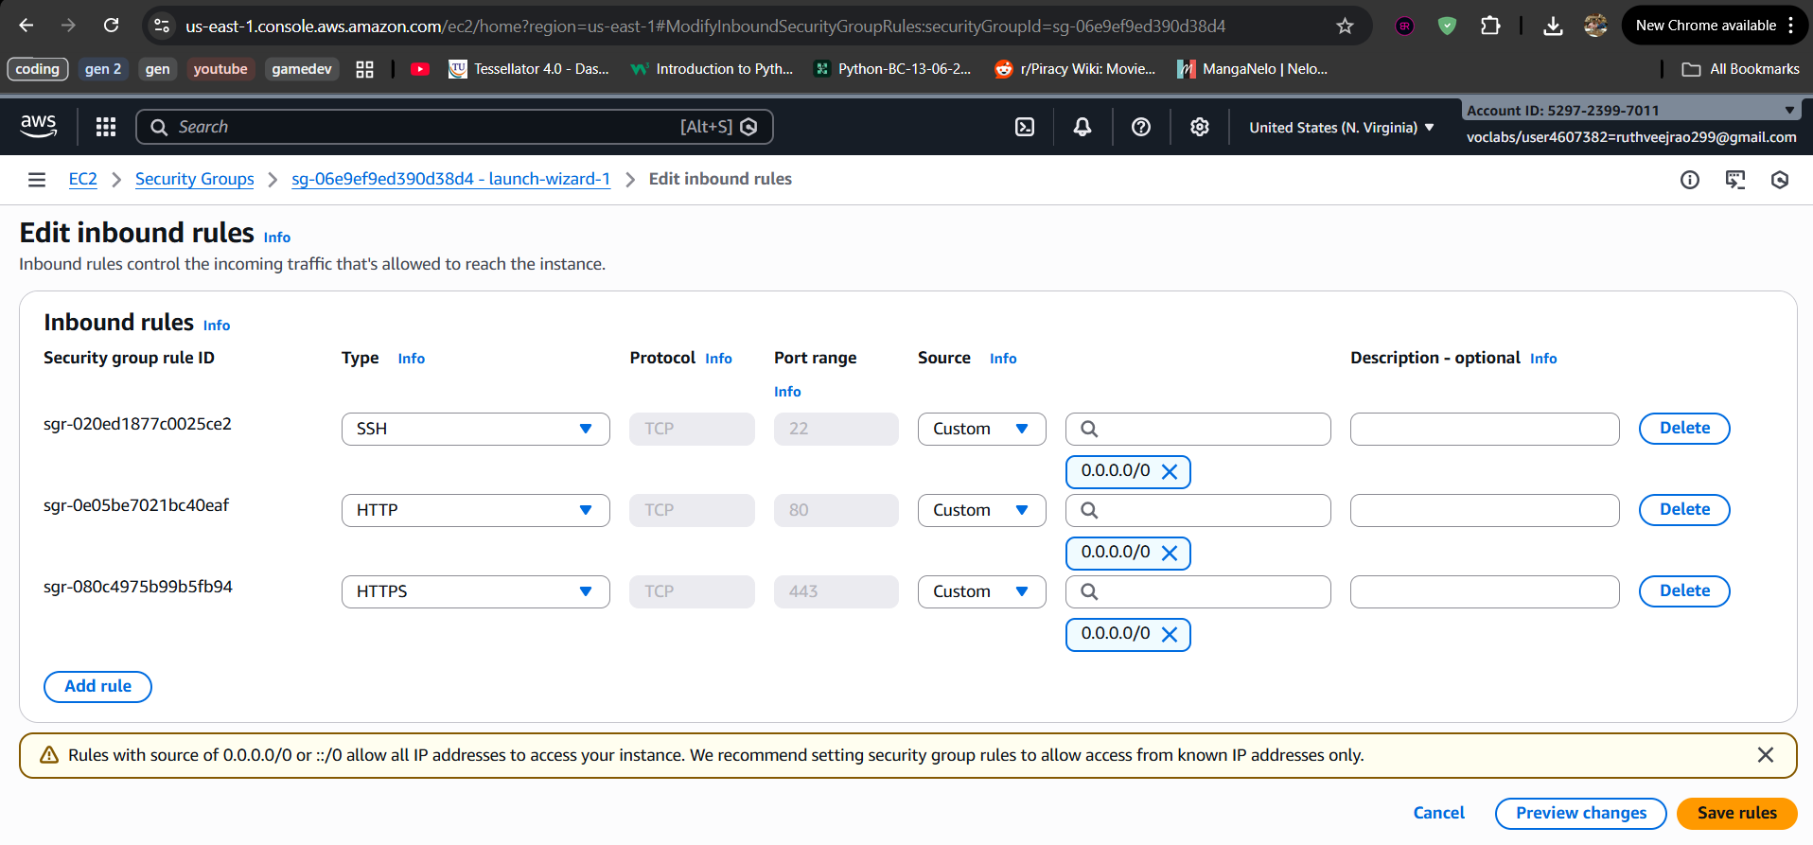

🔹 STEP 2: Open PuTTY
- Launch PuTTY
- In Session screen:
Host Name (or IP address): EC2—CONNECT—COPY (DNS NAME)
ubuntu@<PUBLIC-IP>
Example:
ubuntu@3.110.xxx.xxx
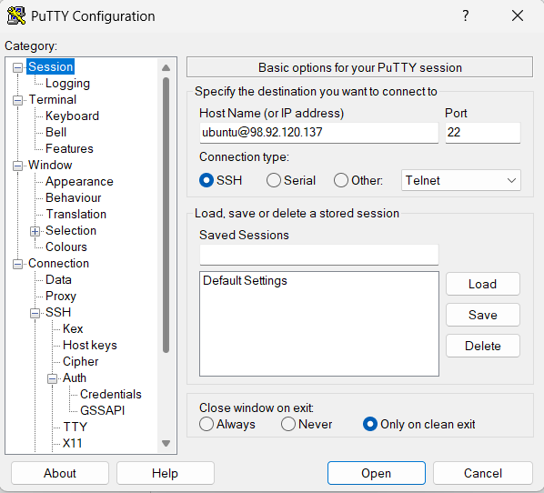

🔹 STEP 3: Attach the .ppk Key
In PuTTY left menu, go to:
Connection → SSH → Auth → Credentials
- Click Browse
- Select your .ppk file
- Click Open
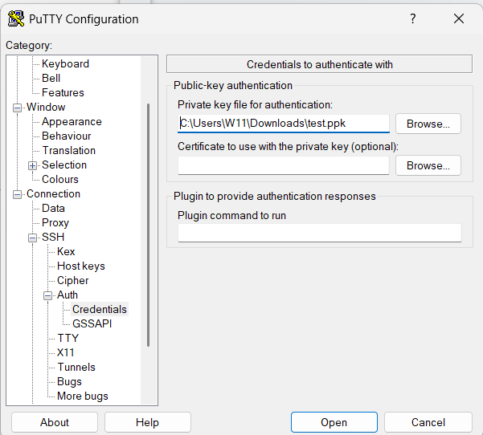

🔹 STEP 4: Connect to EC2
Click Open
- First time → click Yes (security alert)
- PuTTY will log in automatically as:
ubuntu
🎉 You are now connected to your Ubuntu EC2 instance

🧪 VERIFY CONNECTION
Run:
whoami
Output should be:
Ubuntu
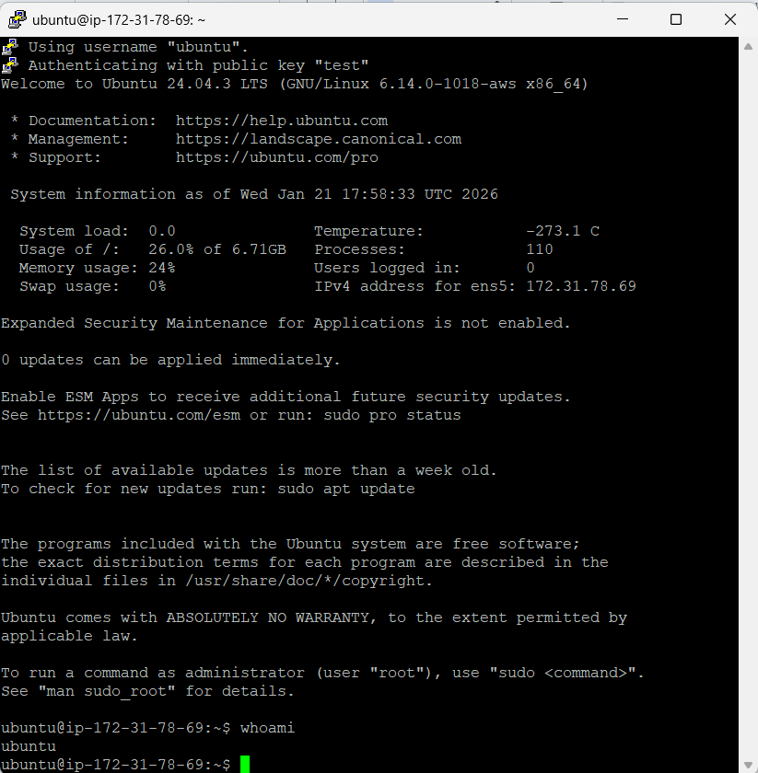

Connect EC2 Ubuntu Instance Using PuTTY (Windows) ---USING PEM KEYPAIR

PREREQUISITES
You must have:
- ✅ EC2 Ubuntu instance running
- ✅ Public IPv4 address (or Elastic IP)
- ✅ Key pair (.pem file) used while launching EC2
- ✅ PuTTY & PuTTYgen installed
👉 Download PuTTY:
https://www.putty.org
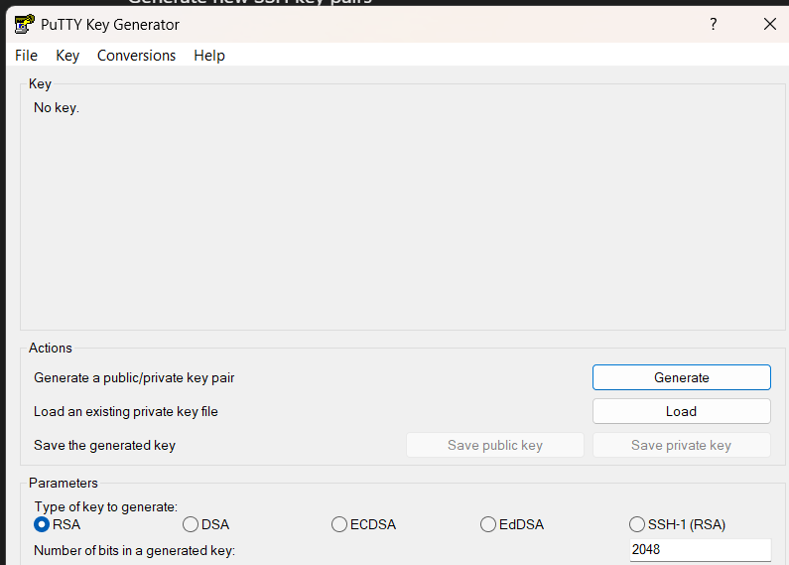

🔹 STEP 1: Convert .pem to .ppk using PuTTYgen
PuTTY cannot use .pem directly.
Steps:
- Open PuTTYgen
- Click Load
- Select your .pem file
(change file type to All Files)
- Click Open
- Click Save private key
- Save as keyname.ppk
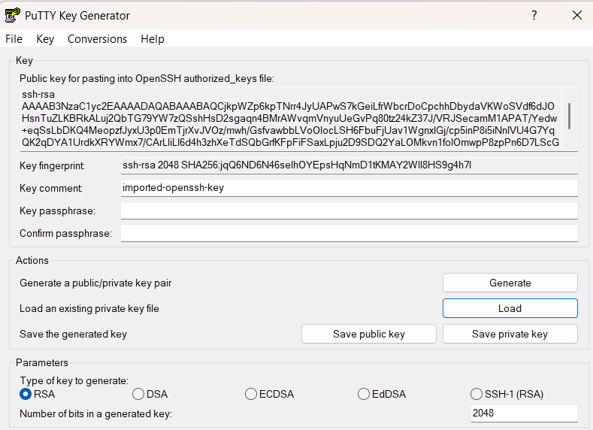
✔ Conversion done

🔹 STEP 2: Get EC2 Public IP
Go to:
AWS Console → EC2 → Instances---CONNECT –COPY DNS NAME

🔹 STEP 3: Configure PuTTY
1️⃣ Open PuTTY
Session:
- Host Name (or IP address): dns name

2️⃣ Load Private Key
Go to:
Connection → SSH → Auth → Credentials
- Click Browse
- Select your .ppk file
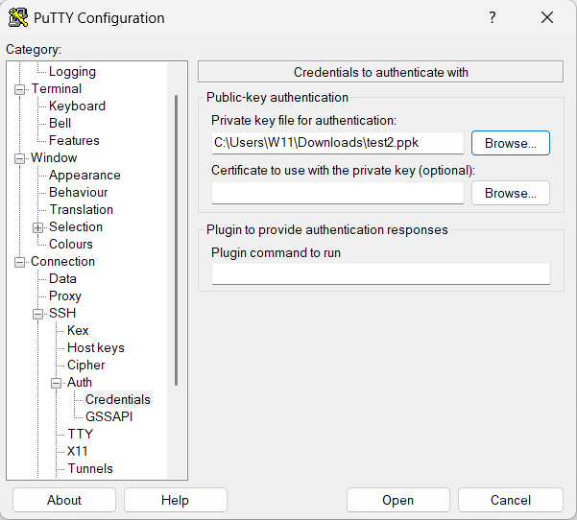

🔹 STEP 4: Connect
Click Open
- First time → click Yes (security alert)
- Login happens automatically as:
ubuntu
🎉 You are now connected to Ubuntu EC2

🧪 VERIFY CONNECTION
Run:
whoami
Output:
Ubuntu
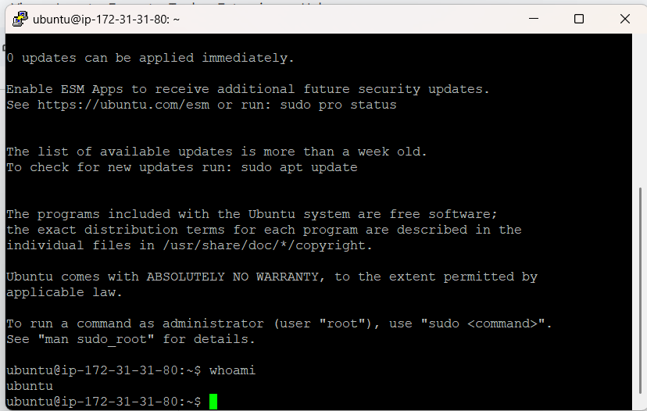

):

Connecting to EC2 Using AWS CloudShell
- Create the EC2 instance using a key pair (.pem).
- Log in to AWS Console and click on the CloudShell icon (terminal icon on the top-right).
- Once CloudShell opens, go to AWS Services → EC2.
- Select your EC2 instance and click Connect.
- Choose the SSH client tab.
- Copy the ssh -i command shown there.
- Paste the command in CloudShell and try to run it.
❌ It will fail with an error like:
“key pair is not available / no such file or directory”
(because the key file is not yet in CloudShell).
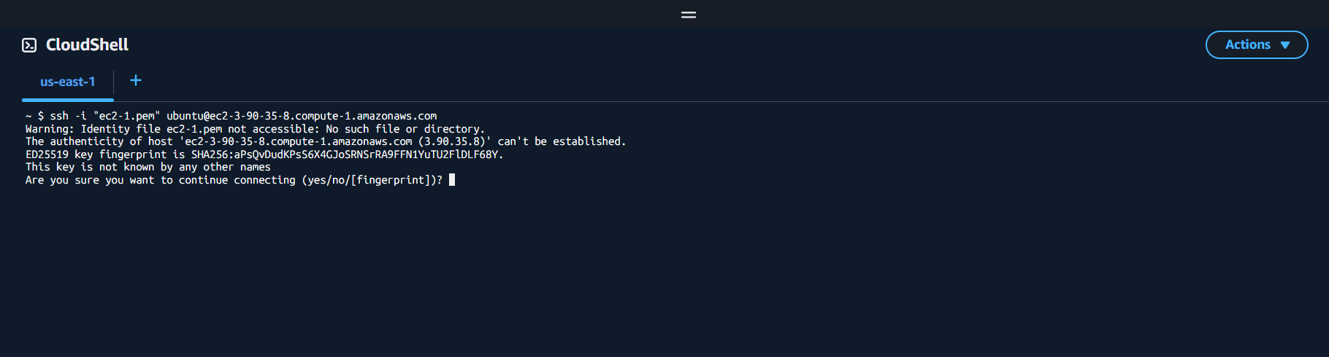
- Now, in CloudShell, click on the “+” (Actions) icon on the right side.
- Select Upload file and upload the key pair (.pem) from your local machine.
- After upload, copy the ssh -i command again from EC2 → Connect → SSH client.
Chmod 400 keyname.pem
- Paste and execute the command in CloudShell.
- ✅ You are now successfully connected to the EC2 instance.
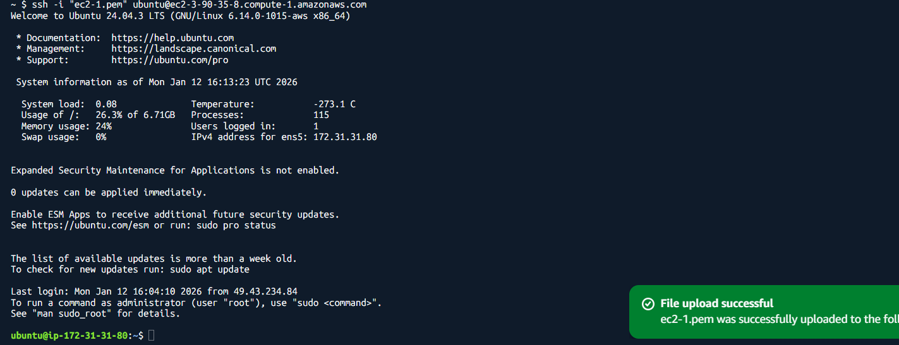

Step-by-Step: Create Windows EC2 Instance and Connect via RDP
Step 1: Launch a Windows EC2 Instance
- Log in to your AWS Management Console.
- Navigate to EC2 → Instances → Launch Instances.
- Select an Amazon Machine Image (AMI):
  - Choose a Windows Server AMI (e.g., Windows Server 2019 or 2022).
- Choose an Instance Type (e.g., t2.micro for free tier or as per your requirement).
- Configure Instance Details as needed.
- Add Storage if required (default is usually sufficient).
- Configure Security Group:
  - Ensure RDP port 3389 is allowed.
  - Source can be My IP (for security) or a wider range if needed.
- Select or create a new Key Pair:
  - Download the .pem file (keep it safe; it’s needed to decrypt the password).
- Click Launch Instance.
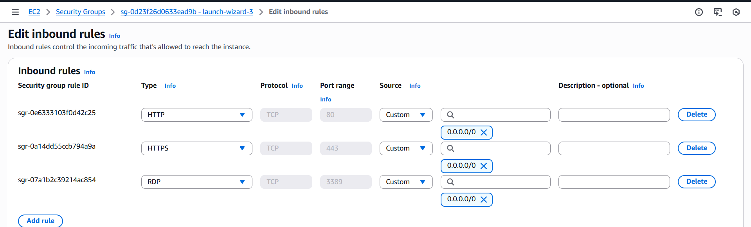

Step 2: Get the Public DNS / IP
- After the instance is running, go to EC2 → Instances.
- Select your instance and note the Public DNS (IPv4) or Public IP.

Step 3: Retrieve the Windows Administrator Password
- Select your instance → Click Connect → RDP Client.
- Click Get Password.
- Upload your Key Pair (.pem) file.
- Click Decrypt Password.
- Copy the Administrator password shown.
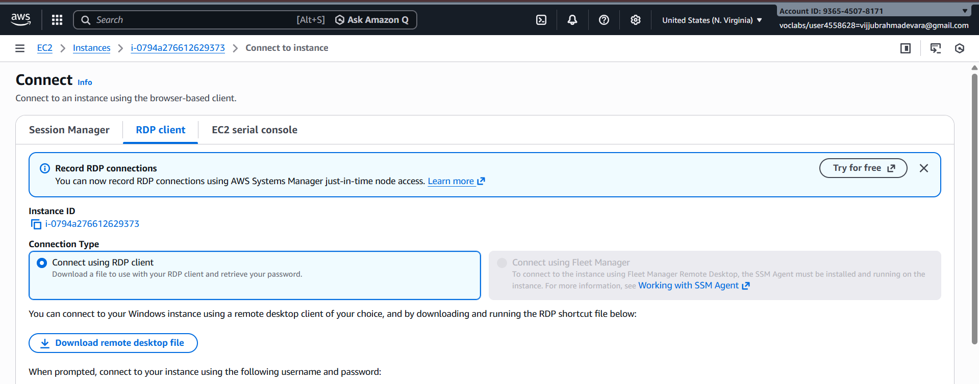
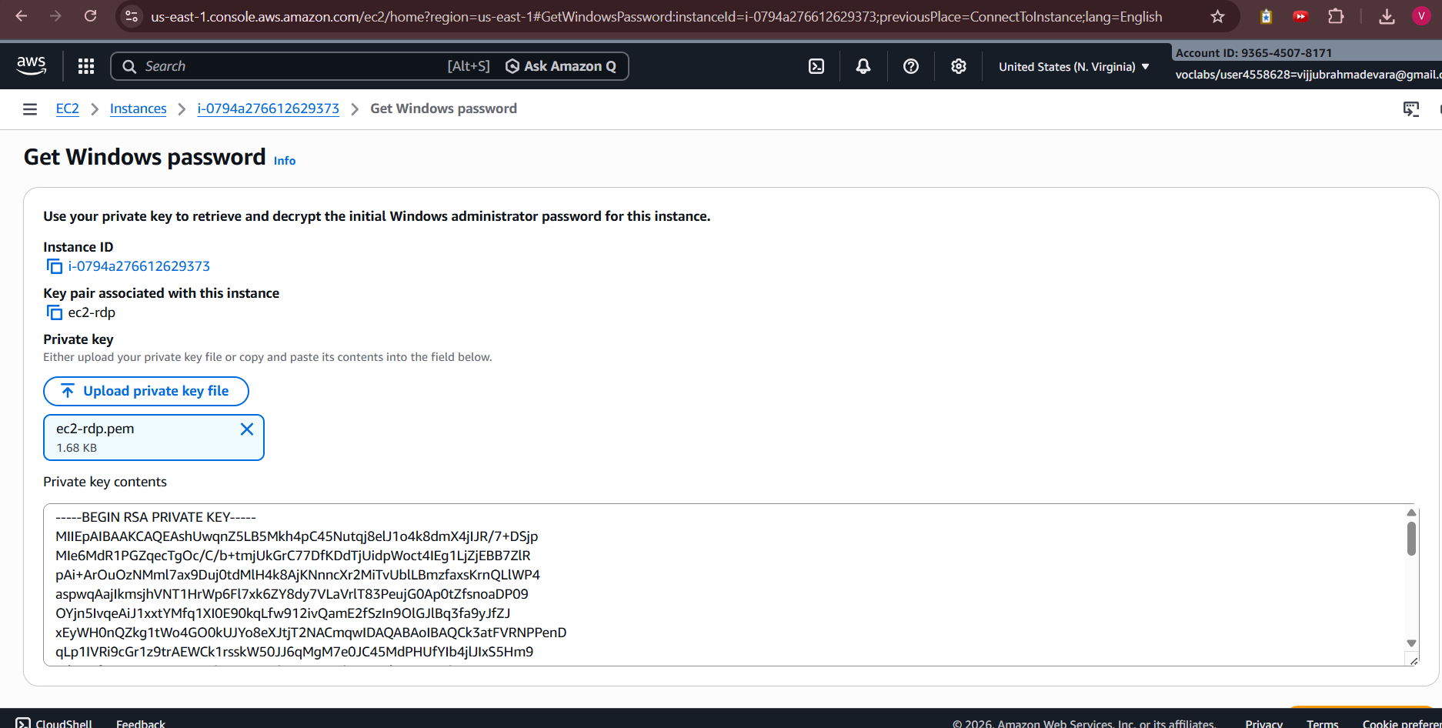
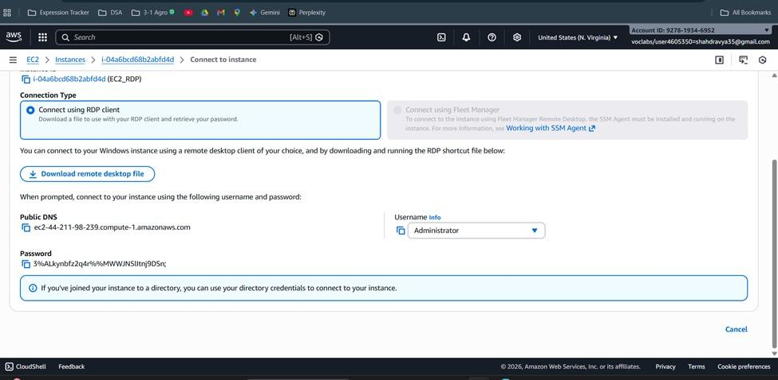

Step 4: Connect via RDP
- On your local Windows machine, open Remote Desktop Connection (mstsc).
- In the Computer field, enter the Public DNS or IP address of the EC2 instance.
- Click Connect.
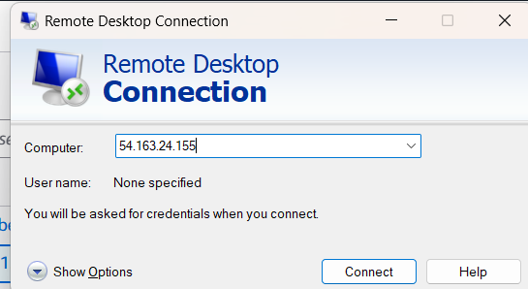
- In the login prompt:
  - Username: Administrator
  - Password: Paste the decrypted password from Step 3.
- Click OK.

Step 5: You’re connected
- Your Windows EC2 instance desktop should appear.
- You can now use it as a normal Windows machine.
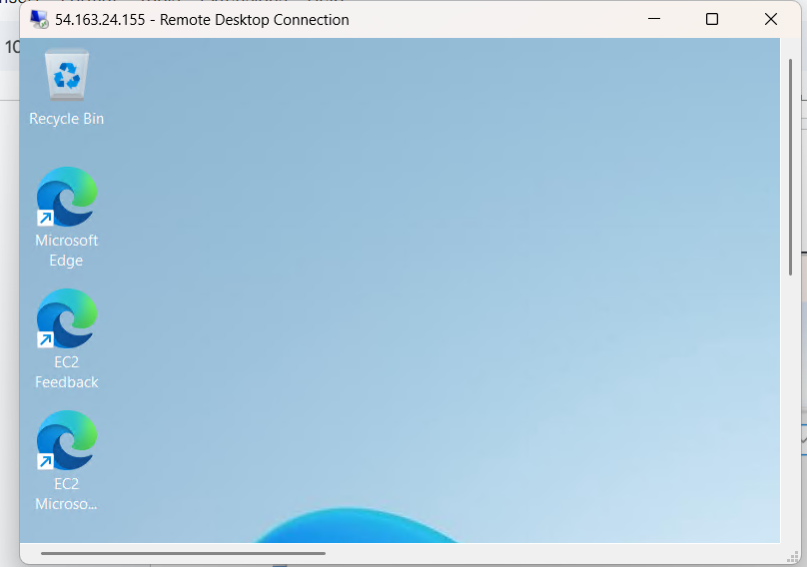

1. What is AWS EC2?
AWS EC2 (Elastic Compute Cloud) is a cloud service from Amazon Web Services that lets you rent virtual servers on demand. You can run applications without owning physical hardware.
Think of it as renting a computer in the cloud, where you can select the CPU, memory, storage, and operating system, and scale resources as needed.

2. Key Components of EC2
An EC2 instance includes several important components:
- Instances: Virtual servers where your applications run.
- Amazon Machine Images (AMI): Pre-built templates with an operating system and software.
- Instance Types: Specify resources like CPU, memory, and storage (e.g., t3.micro, m5.large).
- Elastic Block Store (EBS): Persistent storage that stays even if the instance is stopped.
- Security Groups: Virtual firewalls controlling incoming and outgoing traffic.
- Key Pairs: SSH keys for securely accessing instances.
- Elastic IP: Static public IP addresses that can be assigned to instances.
- VPC (Virtual Private Cloud): Isolated network environment for your instances.

3. How EC2 Works
The basic workflow of EC2:
- Choose an AMI – Pick the operating system and pre-installed software.
- Select Instance Type – Decide the CPU, memory, and storage you need.
- Configure Network & Security – Set up VPC, subnets, security groups, and assign a key pair.
- Launch Instance – AWS provisions the virtual server.
- Connect to Instance – Access it using SSH (Linux) or RDP (Windows).
- Run Applications – Host websites, databases, or any server-based application.

4. Uses of EC2
EC2 can be used for a variety of purposes:
- Hosting websites and web applications.
- Running backend services or APIs.
- Processing large datasets or analytics.
- Training machine learning and AI models.
- Hosting game servers or streaming services.
- Setting up disaster recovery or backup servers.

5. Advantages of EC2
- Scalable – Easily increase or decrease resources.
- Flexible – Choose any OS, CPU, memory, or storage.
- Cost-efficient – Pay only for what you use.
- Highly Available – Deploy across multiple regions or availability zones.
- Secure – Built-in encryption and security through IAM and security groups.

6. Examples
- Hosting a WordPress website on a t3.micro instance.
- Running a Node.js API server for a mobile app.
- Using EC2 instances to build a Spark cluster for big data processing.
- Deploying machine learning models on GPU-enabled instances.

PART 1 — CREATE A LINUX (UBUNTU) EC2 INSTANCE

🌍 STEP 0 — Log into AWS
- Open browser
- Go to: https://aws.amazon.com
- Click Sign In
- Login with your AWS account
After login, you will see the AWS Dashboard.

🔎 STEP 1 — Go to EC2
- In the search bar at top, type:
EC2
- Click EC2
You are now inside the EC2 dashboard.

🚀 STEP 2 — Launch Instance
- Click Launch Instance
Now fill everything carefully.

📝 1. Name the Instance
At top:
Name = MyUbuntuServer
You can name anything. Just remember it.

🖥 2. Choose Operating System (AMI)
Under Application and OS Images
Choose:
Ubuntu Server 22.04 LTS
Make sure it says:
Free tier eligible

⚙ 3. Choose Instance Type
Choose:
t2.micro
(Free tier)

🔐 4. Create Key Pair (VERY IMPORTANT)
This is your login password key.
Under Key pair (login):
Click:
Create new key pair
Fill:
Key pair name: myubuntu-key
Key pair type: RSA
Private key format: .pem
Click:
Create key pair
⚠️ IMPORTANT:
The file will automatically download.
Example:
myubuntu-key.pem
🔴 DO NOT LOSE THIS FILE.
If lost → You cannot login.
Move it somewhere safe like:
Documents → AWS Keys

🌐 5. Configure Security Group
Under Network settings
Click:
Edit
Make sure:
Inbound Rules:
Type: SSH
Port: 22
Source: My IP
If not, add it.
This allows your computer to connect.

💾 6. Storage
Default 8GB is fine.

🚀 7. Launch
Click:
Launch Instance
Wait until:
Instance state = Running

📌 STEP 3 — Copy Important Information
Click your instance name.
You will see details.
You MUST copy these somewhere safe:
Public IPv4 address
Public IPv4 DNS
Instance ID
Example:
Public IP: 3.110.xxx.xxx
Public DNS: ec2-3-110-xxx-xxx.ap-south-1.compute.amazonaws.com
Write them in Notepad.

PART 2 — CONNECT USING PuTTY (.PEM METHOD)

🧰 STEP 1 — Install PuTTY
Download from:
https://putty.org
Install:
- PuTTY
- PuTTYgen

🔁 STEP 2 — Convert .pem to .ppk
PuTTY cannot use .pem directly.
- Open PuTTYgen
- Click Load
- Change file type to:
All Files (*.*)
- Select:
myubuntu-key.pem
- Click Open
- Click:
Save private key
- Save as:
myubuntu-key.ppk
Done ✅

🔌 STEP 3 — Connect Using PuTTY
- Open PuTTY
In Session screen:
Host Name:
ubuntu@YOUR_PUBLIC_IP
Example:
ubuntu@3.110.xxx.xxx
⚠️ Username must be:
ubuntu

🔑 Attach .ppk Key
Left side menu:
Connection → SSH → Auth → Credentials
Click:
Browse
Select:
myubuntu-key.ppk

🚀 Connect
Go back to:
Session
Click:
Open
First time:
Click Yes
You are now connected 🎉

✅ Verify
Type:
whoami
You should see:
ubuntu

PART 3 — CONNECT USING AWS CLOUDSHELL

🖥 STEP 1 — Open CloudShell
Top right corner → Click terminal icon.
CloudShell opens.

📤 STEP 2 — Upload .pem File
In CloudShell:
Click:
Actions (+)
→ Upload file
Upload:
myubuntu-key.pem

🔐 STEP 3 — Change Permission
In CloudShell type:
chmod 400 myubuntu-key.pem
Press Enter.

📋 STEP 4 — Get SSH Command
Go to:
EC2 → Instances → Select instance → Connect → SSH Client
You’ll see something like:
ssh -i "myubuntu-key.pem" ubuntu@ec2-3-110-xxx-xxx.ap-south-1.compute.amazonaws.com
Copy that.

▶️ STEP 5 — Paste in CloudShell
Paste and press Enter.
You are now connected 🎉

PART 4 — CREATE WINDOWS EC2

🚀 STEP 1 — Launch Instance
Same as before.
But choose:
Windows Server 2019 or 2022

🔐 STEP 2 — Key Pair
Create or use existing key pair.
Download .pem.
Keep safe.

🌐 STEP 3 — Security Group
VERY IMPORTANT:
Inbound rules must include:
Type: RDP
Port: 3389
Source: My IP
Without this → RDP will fail.

🚀 Launch Instance
Wait until:
Running

PART 5 — CONNECT WINDOWS USING RDP

🔑 STEP 1 — Get Password
Go to:
EC2 → Select instance → Connect → RDP Client
Click:
Get Password
Upload:
your-key.pem
Click:
Decrypt Password
Copy password.

🖥 STEP 2 — Open Remote Desktop
On Windows:
Press:
Windows + R
Type:
mstsc
Press Enter.

📋 STEP 3 — Enter Public IP
Computer field:
Your Public IP
Click Connect.

🔐 STEP 4 — Login
Username:
Administrator
Password:
(Paste decrypted password)
Click OK.
You are inside Windows EC2 🎉

🔴 WHAT YOU MUST ALWAYS KEEP TRACK OF
Write these in Notepad every time:
For Linux:
- Public IP
- Public DNS
- Key pair name
- .pem file location
- .ppk file location
For Windows:
- Public IP
- .pem key
- Decrypted password

